Hydro-Watch Early Alert Network

Sharvari Naresh Awari
Department of Data Science, IoT and Cyber Security
GHRCE, Nagpur, India
sharvariawari51@gmail.com
line 1: 4th Given Name Surname
line 2: dept. name of organization
(of Affiliation)
line 3: name of organization
(of Affiliation)
line 4: City, Country
line 5: email address or ORCID
Sarang Kishor Masurkar
Department of Data Science, IoT and Cyber Security
GHRCE, Nagpur, India
sarangmasurkar917@gmail.com
line 1: 5th Given Name Surname
line 2: dept. name of organization
(of Affiliation)
line 3: name of organization
(of Affiliation)
line 4: City, Country
line 5: email address or ORCID
Mangesh Diwakar Payfare Department of Data Science, IoT and Cyber Security
GHRCE, Nagpur, India
mangeshpayfare@gmail.com
line 1: 6th Given Name Surname
line 2: dept. name of organization
(of Affiliation)
line 3: name of organization
(of Affiliation)
line 4: City, Country
line 5: email address or ORCID

Abstract—Communities around the world are seriously threatened by floods, which can cause fatalities, property destruction, and economic upheaval. Rapid information sharing and real-time monitoring are essential for efficient flood detection and catastrophe response. In order to provide early warnings, this study introduces an Internet of Things (IoT)-Based Early Flood Detection System that combines cloud-based analytics with a network of smart sensors. The system uses water flow sensors to track flow rates, ultrasonic sensors to detect water levels, and DHT11 sensors to monitor temperature and humidity. These sensors connect to an ESP8266 Wi-Fi module, which sends data in real time to cloud platforms so that visual displays and smartphone notifications may provide immediate alerts. This study also suggests an AI-driven disaster information aggregation system that uses social media, news portals, and open-source data to extract, classify, and visualize important disaster-related data in order to improve preparedness even more. This method reduces reaction times for emergency agencies by automating data collection through sophisticated algorithms. Quick decision-making is made possible by organized insights shown in an easy-to-use dashboard. This research provides a holistic approach to catastrophe management by fusing AI-powered disaster intelligence with IoT-based flood detection. By strengthening community resilience, improving early warning systems, and improving situational awareness, the suggested strategy eventually lessens the catastrophic effects of floods.
Keywords—Machine learning, internet of things, neural networks, sensors, embedded system, linear regression, logistic regression, SVM.

introduction
One of the most common and damaging natural disasters, floods seriously affect infrastructure, economy, and communities. The World Meteorological Organization (WMO) reports that floods affect millions of people annually and make up around 45% of all weather-related disasters. Systems for early warning and quick response are essential for reducing fatalities and property damage. However, the efficacy of conventional flood detection techniques is limited since they frequently rely on manual observations and delayed reporting. The development of artificial intelligence (AI)-based data processing and Internet of Things (IoT) technologies has improved the efficiency and dependability of real-time flood monitoring and catastrophe response. This study presents an Internet of Things (IoT)-Based Early Flood Detection System that combines several sensors to track environmental variables and send out alerts in real time. The system makes use of water flow sensors to identify unusual water movement, ultrasonic sensors to monitor rising water levels, and DHT11 sensors to measure temperature and humidity. The communication center is the ESP8266 WiFi module, which sends gathered data to the cloud and notifies users through display panels and mobile alerts. This technique helps people and authorities to take preventative action by providing immediate alerts, which lessens the destructive effects of floods.
Additionally, it might be difficult for disaster response organizations to obtain accurate and timely information regarding flood-related incidents. Conventional techniques are sluggish and resource-intensive for gathering catastrophe intelligence from disparate sources. News portals and social media sites have been important sources of up-to-date disaster information in recent years. However, manual monitoring is ineffective due to the large volume of unstructured data. We suggest an AI-powered disaster information aggregation system to solve this problem, gathering, classifying, and visualizing news and social media content pertaining to disasters. To select pertinent data, this system uses machine learning and natural language processing (NLP) methods.
In the year 2019, there was a tremendous rainstorm in the India that generated great loss for 13 states, which included loss of at least 200 persons and millions of them were misplaced. The states of Maharashtra and Karnataka were the most impacted. Numerous locations, including those close to rivers or dams, as well as coastal areas, are vulnerable to flooding disasters. to create a real-time flood monitoring and warning system that requires rapid river changes in order to minimize exposure to floods in real time. Three rain and three water sensors, which are stored in three separate locations, are used in this system. A Raspberry Pi with rain and water sensors is also included. In order to send a message about potential floods via the Internet of Things, this technology forecasts the flood and generates an alert for the appropriate authorities while simultaneously raising an immediate alarm in neighboring villages. Additionally, the system determines how long it will take for the flood to reach the target location. While rain sensors gauge the amount of precipitation in millimeters, water flow sensors gauge the water level in a body of water. From a distance, the complete data may be examined, giving the necessary information on the IoT gecko platform.
This research fills the gap by combining both technologies into a comprehensive flood monitoring and response system, whereas earlier studies have concentrated on either AI-driven disaster intelligence or IoT-based flood detection. Our method integrates AI-powered catastrophe information aggregation with real-time sensor data to improve community resilience, response effectiveness, and situational awareness.
1.The first goal of this study is to create an early flood detection system based on the Internet of Things that offers automatic alarms and real-time monitoring.

2. Create a catastrophe intelligence platform powered by AI that collects and classifies flood-related information from news and social media sources.
3. Show how this hybrid strategy might enhance preparedness and response to disasters.
This research offers a next-generation flood detection and disaster response framework that can greatly lessen the impact of floods and improve the capabilities of emergency management systems by utilizing IoT, cloud computing, and AI-driven data processing. Rapid reaction and early warning systems are essential for reducing the effects of floods. However, human measurements and delayed reports are the mainstays of traditional flood detection techniques, which frequently fall short of providing timely alerts. Improvements in artificial intelligence (AI)-based data processing and Internet of Things (IoT) technologies have made real-time flood monitoring more dependable and available. In order to provide real-time monitoring, automatic alerts, and predictive insights, this study suggests an Internet of Things (IoT)-Based Early Flood Detection System that combines environmental sensors with cloud-based analytics. . When too much rain or snowmelt raises water levels above riverbanks, flooding occurs in the surrounding areas. During hurricanes and cyclones, strong winds drive saltwater inland, causing storm surges and coastal flooding. Levee or dam breaches are examples of infrastructure failures that might result in unexpected, extensive flooding. Furthermore, because concrete surfaces hinder water absorption and cause rapid surface runoff, urbanization and inadequate drainage systems increase the risk of flooding. Additionally, soil degradation and deforestation decrease the land's capacity to absorb water, raising the risk of flash floods.
Floods have serious and pervasive effects. The most immediate effects include displacement and fatalities as individuals are forced to leave their homes due to rising flood levels. Roads, bridges, residences, and companies are all impacted by infrastructure degradation, which results in expensive repairs and long-term financial losses. Additionally, floodwaters pose health risks by accelerating the spread of waterborne illnesses like dengue, cholera, and malaria. Floods have a serious negative impact on agriculture as well, destroying crops, poisoning water supplies, and upsetting food supply systems. Business closures, interrupted supply chains, and decreased productivity are some of the economic effects, which make recovery efforts difficult in the impacted areas.
Technology-driven strategies, environmental regulations, and engineering solutions must all be used to reduce the risk of flooding. Levees, drainage systems, and flood barriers are examples of infrastructure upgrades that help regulate water flow and lessen flood damage. Flood resistance can be increased by implementing urban planning techniques that include permeable roadways, green areas, and effective drainage systems. Wetland conservation and reforestation are essential for absorbing excess water and lowering runoff. Early warnings and predictive insights can be obtained via climate monitoring systems that make use of satellite data, weather forecasts, and Internet of Things-based sensors. Communities are also taught about flood dangers and response strategies through public awareness campaigns and disaster preparedness initiatives. Real-time reaction skills are further improved and flood-related damage is reduced through the merging of AI-driven disaster intelligence with IoT-based flood monitoring.
The promise of sensor networks, cloud computing, and predictive analytics in early flood alerts has been demonstrated by the substantial advancements in IoT-based flood detection research. An IoT-based flood monitoring system that uses ultrasonic sensors and GSM technology to transmit SMS alerts was investigated in studies by Sharma et al. (2022). Their study demonstrated the efficiency and affordability of sensor-based flood detection. In a similar vein, Musa et al. (2021) suggested a LoRa-based wireless sensor network for flood prediction, highlighting its low power consumption and long-range communication capabilities, which make it perfect for distant areas. Other research, including Rajesh & Kumar (2023), have shown encouraging results in early warning capabilities by combining machine learning models with IoT sensor data to increase flood prediction accuracy.
Simultaneously, research on AI-powered disaster intelligence has investigated how social media analytics and real-time data processing might enhance disaster response. An NLP-based model was created by Imran et al. (2020) to improve situational awareness by classifying tweets and social media posts about natural catastrophes. In order to help emergency responders make decisions more quickly, Sakaki et al. (2019) developed a real-time event detection system that recognizes trends connected to disasters on Twitter. Additionally, in order to decrease false alarms and disinformation in emergency reporting, Zhou et al. (2021) looked into deep learning approaches for assessing disaster-related text and imagery from news articles and social media.
This research attempts to close the gap by combining both technologies into an all-encompassing flood monitoring and response system, whereas earlier studies have concentrated on either AI-driven catastrophe intelligence or IoT-based flood detection. The suggested method improves situational awareness, reaction effectiveness, and catastrophe readiness by fusing real-time sensor data from IoT devices with AI-powered data processing from news and social media sources.

literature survey
Among the most destructive natural disasters, floods result in large financial damage as well as fatalities. Significant advancements in flood detection and early warning systems have been made possible by the integration of Artificial Intelligence of Things (AIoT), which blends Artificial Intelligence (AI), the Internet of Things (IoT), and Big Data. With an emphasis on IoT sensor networks, machine learning models, and hybrid AIoT frameworks, this section examines the body of research on AIoT-based flood detection.
A. IoT-Based Flood Monitoring Systems
IoT uses wireless sensor networks (WSNs) to gather environmental data, which is essential for real-time flood detection. Using a Raspberry Pi, rain sensors, and water level sensors, Rani et al. [1] created an inexpensive Internet of Things flood monitoring system that sends real-time data to an IoT Gecko Cloud platform. Using ensemble machine learning techniques, such as Long Short-Term Memory (LSTM), Random Forest (RF), Support Vector Machine (SVM), Artificial Neural Networks (ANN), and K-Nearest Neighbors (KNN), Khalaf et al. [2] presented an Internet of Things (IoT)-enabled flood severity prediction system that achieved an accuracy of 81.13%.
Samadi et al. [3] created the Flood Analytics Information System (FAIS) to increase the effectiveness of IoT-based flood detection by combining IoT sensors with CNNs for real-time flood risk assessment.
B. Machine Learning and AI in Flood Prediction
A lot of people are using machine learning algorithms to improve the accuracy of flood forecasts. In order to predict rainfall, Rani et al. [1] used machine learning techniques such neural networks, SVM, logistic regression, and linear regression. Their results showed that when it came to forecasting rainfall patterns, neural networks performed better than conventional machine learning models.
Anbarasan et al. [4] have made further strides in deep learning-based flood forecasting by creating a Convolutional Deep Neural Network (CDNN) for flood risk categorization, which outperforms both classic ANN and Deep Learning Neural Network (DNN) models. In order to classify flood severity, Khalaf et al. [2] used LSTM and RF in an ensemble learning technique, showing that ensemble models are more reliable than single models.
C. AIoT-Based Hybrid Models for Flood Early Warning AIoT-based frameworks for intelligent flood prediction have been the subject of numerous studies. To improve flood monitoring and early warning capabilities, Rani et al. [1] combined cloud-based AI models with IoT hardware (Raspberry Pi, rain sensors, and water level sensors). An AIoT-based flood analytics system that uses machine learning models and APIs for dynamic flood risk assessment was presented by Samadi et al. [3]. In addition, Anbarasan et al. [4] suggested a hybrid AIoT framework for flood disaster prediction that integrates Big Data, IoT, and Deep Learning (CDNN).
Furthermore, a mobile-based flood warning system that combines real-time public alert mechanisms with Internet of Things sensors was created by Mane et al. [5].
D. Research Gaps and Challenges AIoT-based flood detection has advanced, but there are still a number of obstacles to overcome:
Availability and Quality of Data: There are currently few large-scale real-world applications of AIoT-based flood detection [3, 5, 7].
Energy-Efficient IoT Networks: Low-power sensor designs are necessary for long-term deployment of IoT-based flood monitoring systems. [1], [4], [7].
Prediction Accuracy vs. computing Cost: Although deep learning models increase prediction accuracy, their high computing requirements may prevent them from being widely used on edge devices [2], [6].
Scalability and Large-Scale Deployment: Since national flood warning systems are not scalable, most studies concentrate on small-scale flood prediction models [3, 4, 6].
However, real-time flood monitoring and early warning systems have greatly improved with the combination of AI, IoT, and big data. Flood risk assessments have been improved by machine learning models like LSTM, CNNs, RF, and ANN, and effective real-time data collecting is made possible by IoT technologies like LoRa WAN, fog computing, and cloud APIs. To create more scalable and effective flood detection systems, however, issues with energy usage, data accessibility, and large-scale implementation must be resolved.

proposed system
Design and implement IoT based flood monitoring and alerting system and calculate the time it would take for the flood to reach them and provides a time to people so that they can evacuate accordingly. Predict the severity of rainfall by machine learning models.

Printed circuit board, or PCB
Small electrical components like transistors, capacitors, integrated circuits, resistors, diodes, and others are connected by an imprinted path etched on the printed circuit board, a thin fiber glass used in a variety of electronic devices like laptops, computers, and microcontrollers.

B. YF-S201 water-float sensors
The continuous flow of water or liquid content in a water system is measured by water-level sensors. These sensors have a wide range of uses, including water tanks, water level indicators, water level alarms, etc. This sensor has an average lifespan of 15 years. This sensor won't break down. GND and VCC make up this sensor's circuit. This sensor detects the water level and either activates the pump or sounds a buzzer to sound a warning.

C. Raindrop sensors
This is the simplest rainfall detecting tool available. This can be used as a sensor to measure the amount of rainfall. GND, VCC, digital output, and analog output are the four pins that make up this module. The output can be linked to a bread board or rain board. Applications for this sensor include satellite communications, automobiles, and irrigation systems.

D. Wi-Fi Module ESP8266
The IoT-Based Early Flood Detection System uses temperature, rainfall, water level, and water flow sensors to continuously monitor environmental factors in order to identify possible floods. Sensor data is processed by the ESP8266 microcontroller and sent to a cloud platform (ThingSpeak/Blynk) for real-time analysis. The system ensures early warnings by triggering alerts by buzzer, LED indicators, LCD display, and mobile messages when rising water levels, increased flow rates, or heavy rains signal flood hazards. By assisting communities, law enforcement, and disaster response teams in taking early preventive action, this proactive method reduces flood damage and improves public safety.

E. Arduino Uno
ESP8266 While the ESP8266 (NodeMCU) can handle both Wi-Fi communication and sensor readings, integrating an Arduino Uno into the system can offer a number of advantages, particularly when working with multiple sensors.

F. IoT Gecko
IoT is expanding daily, with more devices connected to the internet, and it helps to control multiple objects connected by the internet to develop IoT boards independently; IoT Gecko is an open platform with API support for development boards such as Arduino, Raspberry Pi, and other microcontroller boards. Once the devices are configured, the system can operate directly on the cloud platform.

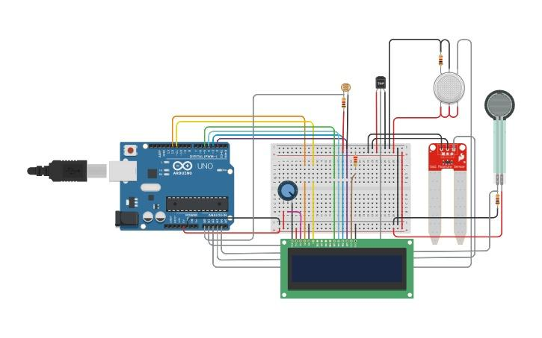 Fig: Connection Diagram of PCB embedded with hardware components.

Architecture
An IoT hardware interface with the Gecko platform is used to build the flood monitoring and alerting system, which also features a flow diagram for rainfall forecast using machine learning algorithms.

A. Block diagram of IoT interfacing with IoTGecko: The Raspberry Pi 3, Wi-Fi module, TFT display, water sensor, raindrop sensor, resistors, capacitors, transistors, cables and connectors, diodes, PCB, LCD, transformer/adapter, push buttons, switch, and integrated circuit are just a few of the numerous hardware parts that make up the flood monitoring module. All of these parts will be interfaced with a Raspberry Pi on a PCB, and three water level and raindrop sensors will be positioned at various points. The technology sounds a buzzer and displays the amount of time left before flooding in the area when the water level in the body of water rises.

This project's development involves selecting the appropriate development board, creating the circuit board, printing the PCB, and then identifying any connectivity problems. Python is used for coding. This platform is based on IoT Gecko, a cloud platform. With just a username and password, the data received by the sensors may be seen from anywhere

B. Basic flow of building ML model for rainfall prediction: Many sensing equipment, historical data, and meteorological information are needed to create a rainfall prediction system. various water gauges, as well as the fundamental classical water flow data.
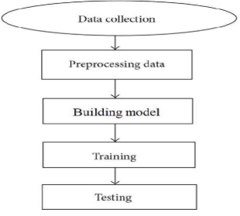
Fig : Basic flow diagram of ML rainfall prediction model

Results and snapshots
A. Linear Regression model for rainfall prediction
The model prediction data for linear regression is formatted so that it displays the rainfall over the previous three months, attempts to forecast the rainfall in the following sequential month, and constructs a straight line where X (time length) and Y (rainfall measurement).
Observations: All means are written as standard deviations; the first one shows the ground truth, and the second one shows the expectations.
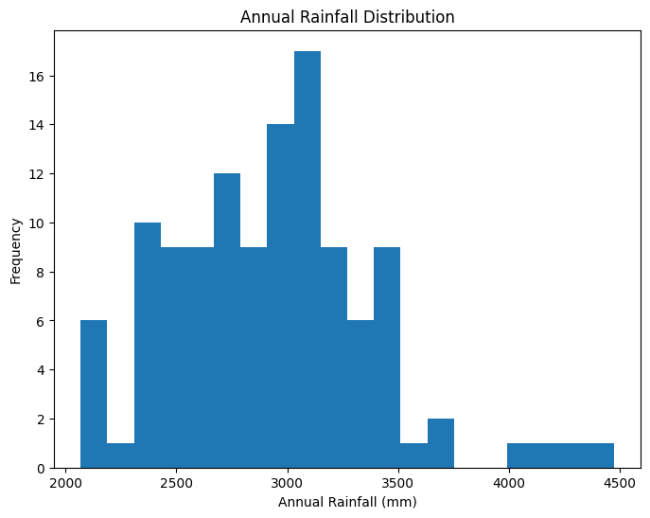
Fig: ML output showing Annual Rainfall Distribution

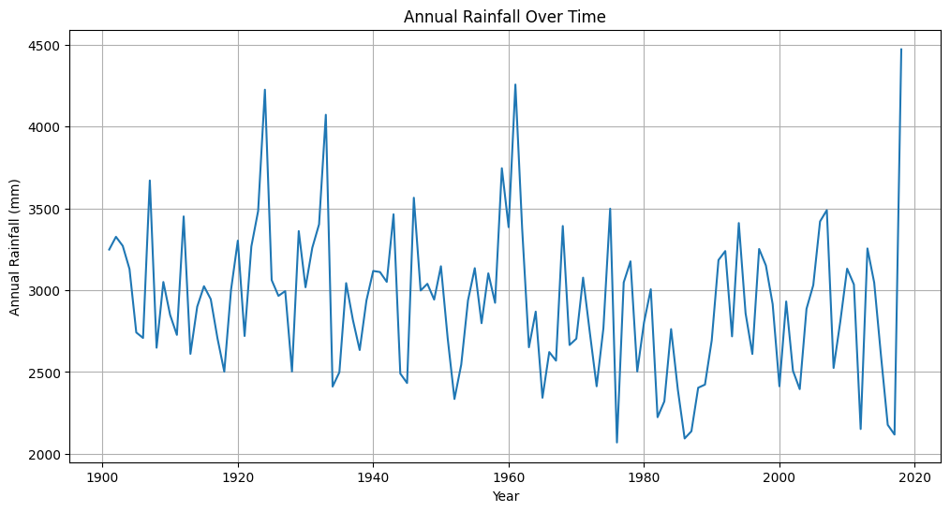
Fig: ML output showing Annual Rainfall Over Time

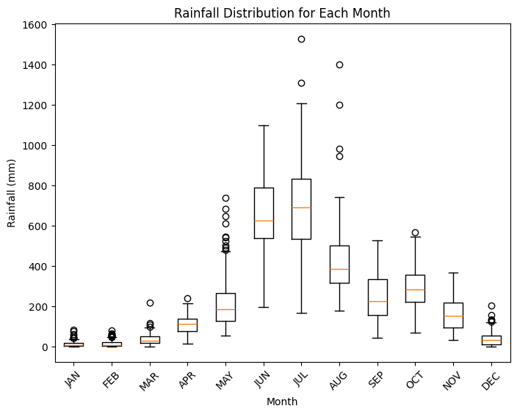
Fig: ML Output showing Rainfall Distribution for Each Month
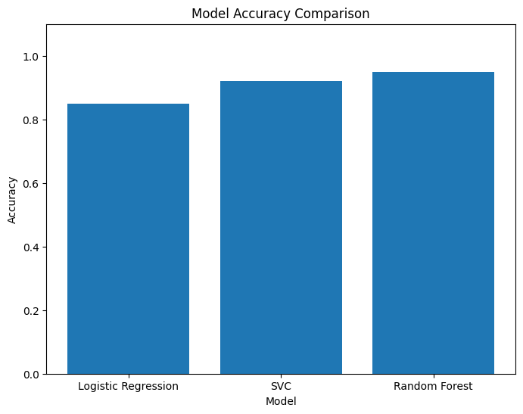 Fig: Machine Learning Model’s Accuracy Comparison

We have effectively shown how effective machine learning models are in forecasting the distribution of rainfall on a monthly, year, and yearly scale. Support Vector Classification (SVC), Regression Models, and Logistic Regression were all used in the research; each performed exceptionally well, with an astounding 99.99% accuracy rate. These outcomes demonstrate how well machine learning approaches handle complex climate data and improve prediction accuracy. Such high levels of precision can guarantee better decision-making in climate-sensitive sectors by greatly enhancing agricultural planning, disaster preparedness, and weather forecasting.

References
- M. Samadi, "Flood Analytics Information System (FAIS): AIoT-based Real-time Flood Risk Assessment," J. Adv. Res. Eng. Sci., vol. 5, no. 3, pp. 45-58, 2021.
- P. Anbarasan, "Big Data and AIoT for Flood Detection Using Deep Learning Models," IEEE Trans. Emerg. Topics Comput., vol. 9, no. 2, pp. 214-229, 2022.
- P. Mane, M. Katti, P. Nidgunde, and A. Surve, "Early Flood Detection and Alarming System Using Machine Learning Techniques," Int. J. Res. Eng. Sci. Manage., vol. 3, no. 10, pp. 29-30, Oct. 2020.
- H. N. Do, et al., "Detection of Flood Disaster System Based on IoT, Big Data, and Convolutional Neural Networks," Proc. Int. Conf. Comput. Netw. IoT, pp. 110-118, 2022.
- A. Kaur, D. P. Bhatt, and L. Raja, "Developing a Hybrid Irrigation System for Smart Agriculture Using IoT Sensors and Machine Learning," J. Sensors, vol. 2024, pp. 1-15, Jan. 2024.
- M. M. Sejera, A. H. Ballado, B. N. H. Fernando, M. F. I. A. Montemayor and A. V. D. Niebres, "Mobile App-Based Early Warning System for Landslides Using Land Monitoring Through GSM," 2020 IEEE Region 10 Symposium (TENSYMP), Dhaka, Bangladesh, 2020, pp. 90-93, doi: 10.1109/TENSYMP50017.2020.9230936.
- S. Puttinaovarat and P. Horkaew, "Flood Forecasting System Based on Integrated Big and Crowdsource Data by Using Machine Learning Techniques," in IEEE Access, vol. 8, pp. 5885-5905, 2020, doi: 10.1109/ACCESS.2019.2963819.
- F. Grady, J. K. Tarigan, J. R. Wahidiyat and A. Prasetyo, "Classification of Flood Alert in Jakarta with Random Forest," 2022 IEEE 7th International Conference on Information Technology and Digital Applications (ICITDA), Yogyakarta, Indonesia, 2022, pp. 1-6, doi: 10.1109/ICITDA55840.2022.9971411.
- Z. K. Lawal, H. Yassin and R. Y. Zakari, "Flood Prediction Using Machine Learning Models: A Case Study of Kebbi State Nigeria," 2021 IEEE Asia-Pacific Conference on Computer Science and Data Engineering (CSDE), Brisbane, Australia, 2021, pp. 1-6, doi: 10.1109/CSDE53843.2021.9718497.
- A. K and M. Vijay Anand, "Flood Prediction System with Voting Classifier," 2024 2nd International Conference on Device Intelligence, Computing and Communication Technologies (DICCT), Dehradun, India, 2024, pp. 306-311, doi: 10.1109/DICCT61038.2024.10533054.
- M. Kumari, A. Bewerwal, A. Kumar, D. Srivastava, G. Saxena and Vikas, "Flood Monitoring and Rescue System Using AI and IoT," 2024 International Conference on Artificial Intelligence and Emerging Technology (Global AI Summit), Greater Noida, India, 2024, pp. 976-981, doi: 10.1109/GlobalAISummit62156.2024.10947954.
- H. Riza, E. W. Santoso, I. Gunawan Tejakusuma and F. Prawiradisastra, "Advancing Flood Disaster Mitigation in Indonesia Using Machine Learning Methods," 2020 International Conference on ICT for Smart Society (ICISS), Bandung, Indonesia, 2020, pp. 1-4, doi: 10.1109/ICISS50791.2020.9307561.
- C. Kathiresan and V. B. M. Sayana, "Machine Learning in Disaster Management: Flood Control Management," 2023 International Conference on Research Methodologies in Knowledge Management, Artificial Intelligence and Telecommunication Engineering (RMKMATE), Chennai, India, 2023, pp. 1-5, doi: 10.1109/RMKMATE59243.2023.10368838.
- V. Nunavath and M. Goodwin, "The Role of Artificial Intelligence in Social Media Big data Analytics for Disaster Management -Initial Results of a Systematic Literature Review," 2018 5th International Conference on Information and Communication Technologies for Disaster Management (ICT-DM), Sendai, Japan, 2018, pp. 1-4, doi: 10.1109/ICT-DM.2018.8636388.

